**-- create the database**

create database bus_transport_system;

-- \c bus_transport_system;

**-- create the route table**

CREATE TABLE route ( route_no INT PRIMARY KEY, source CHAR(20), destination CHAR(20), no_of_stations INT );

**-- create the bus table**

create table bus (bus_no int primary key, capacity int not null depot_name varchar(20),route_no int references route(route_no));

**-- create the driver table**

CREATE TABLE driver ( driver_no INT PRIMARY KEY, driver_name CHAR(20), license_no INT UNIQUE, address CHAR(20), d_age INT, salary FLOAT );

**-- create the bus_driver table to represent the many-to-many relationship between bus and driver**

CREATE TABLE bus_driver ( bno INT, dno INT, dated DATE, shift VARCHAR(10), FOREIGN KEY (bno) REFERENCES bus(bus_no), FOREIGN KEY (dno) REFERENCES driver(driver_no) );

**-- insert sample data into the route table**

INSERT INTO route (route_no, source, destination, no_of_stations) VALUES (1, 'a', 'b', 5), (2, 'c', 'd', 7), (3, 'a', 'd', 10), (4, 'e', 'f', 6), (5, 'b', 'c', 8);

**-- insert sample data into the bus table**

INSERT INTO bus (bus_no, capacity, depot_name, route_no) VALUES (101, 50, 'central depot', 1), (102, 45, 'east depot', 2), (103, 60, 'central depot', 1), (104, 55, 'west depot', 3), (105, 50, 'south depot', 4);

**-- insert sample data into the driver table**

INSERT INTO driver (driver_no, driver_name, license_no, address, d_age, salary) VALUES (1, 'john smith', 12345, '123 main st', 35, 50000), (2, 'alice johnson', 23456, '456 oak ave', 40, 60000), (3, 'bob williams', 34567, '789 pine ln', 45, 70000), (4, 'mary brown', 45678, '246 elm st', 30, 55000), (5, 'david davis', 56789, '135 maple dr', 50, 80000);

**-- insert sample data into the bus_driver table**

INSERT INTO bus_driver (bno, dno, dated, shift) VALUES (101, 1, '2024-01-01', 'morning'), (101, 2, '2024-01-01', 'evening'), (102, 3, '2024-01-02', 'morning'), (103, 1, '2024-01-02', 'evening'), (104, 4, '2024-01-03', 'morning'), (105, 5, '2024-01-03', 'evening'), (101, 3, '2024-01-04', 'morning');

**Output:** 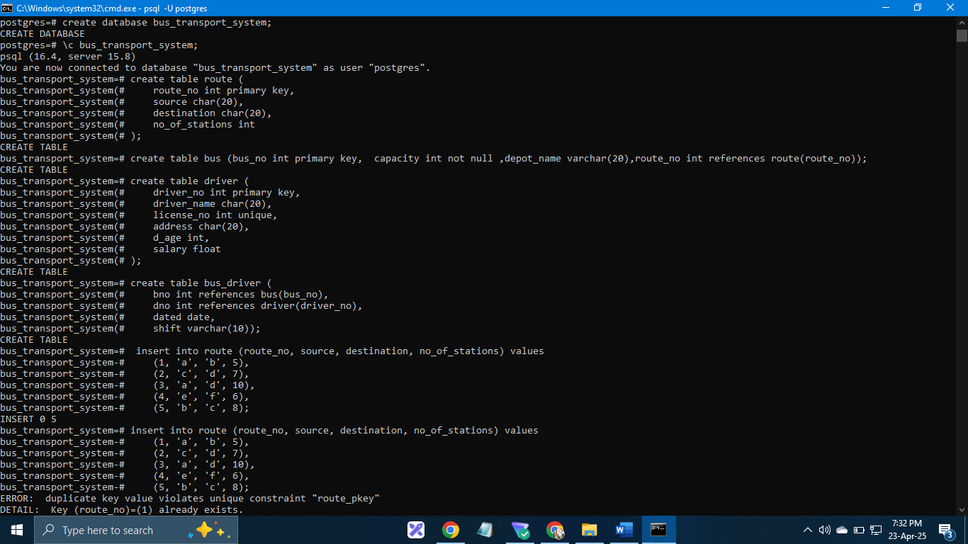

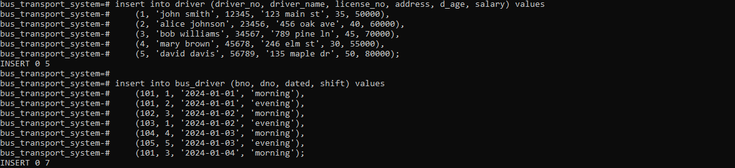

**Questions :**

**-- a) pl/pgsql function to find the name of the driver having the maximum salary**

create or replace function get_max_salary_driver()

returns text as $$

declare

max_salary_driver_name text;

begin

select driver_name into max_salary_driver_name

from driver

where salary = (select max(salary) from driver);

return max_salary_driver_name;

end;

$$ language plpgsql;

-- example usage:

**-- select get_max_salary_driver();**

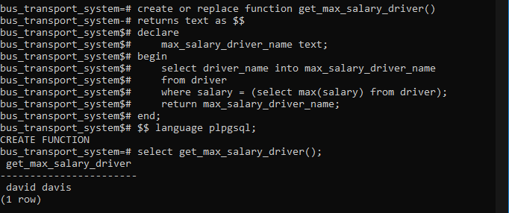

**-- b) pl/pgsql function to accept bus_no and date and print its allotted driver name**

create or replace function get_driver_name_for_bus_and_date(p_bus_no int, p_date date)

returns text as $$

declare

    driver_names text ;

begin

    select d.driver_name into driver_names

    from driver d

    join bus_driver bd on d.driver_no = bd.dno

    where bd.bno = p_bus_no and bd.dated = p_date;

    if driver_names = '' then

        return 'no drivers found for the given bus and date.';

    else

        return driver_names;

    end if;

end;

$$ language plpgsql;

-- example usage:

**-- select get_driver_name_for_bus_and_date(101, '2024-01-01');**

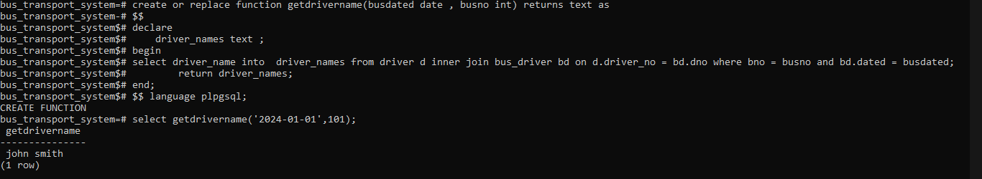

**-- c) pl/pgsql function to change the destination for a given source**

create or replace function replace_dest(routeno int,s text,d text ,cd text) returns text as

$$

begin

update route set destination = cd where route_no = routeno and source=s and destination=d ;

return cd;

end;

$$

language plpgsql;

select replace_dest(1,'a','b','e');

select * from route;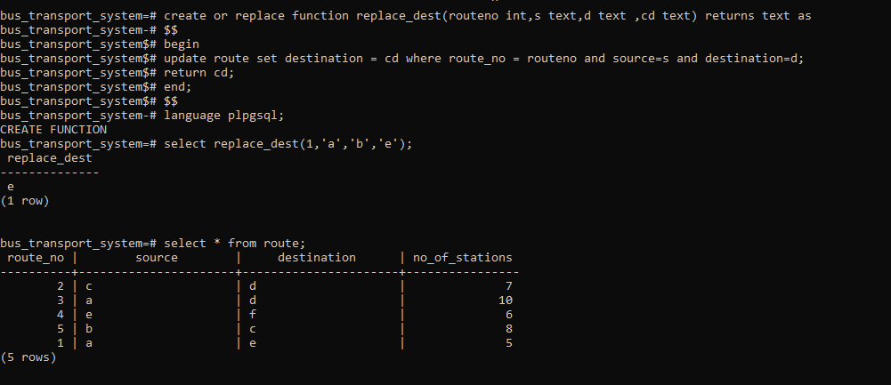

**-- d) pl/pgsql function to accept driver number and remove his details from the database**

create or replace function deletedriver(dn int) returns int as

$$

begin

delete from bus_driver where dno = dn;

delete from driver where driver_no = dn;

return dn;

end;

$$

language plpgsql;

`select deletedriver(5);

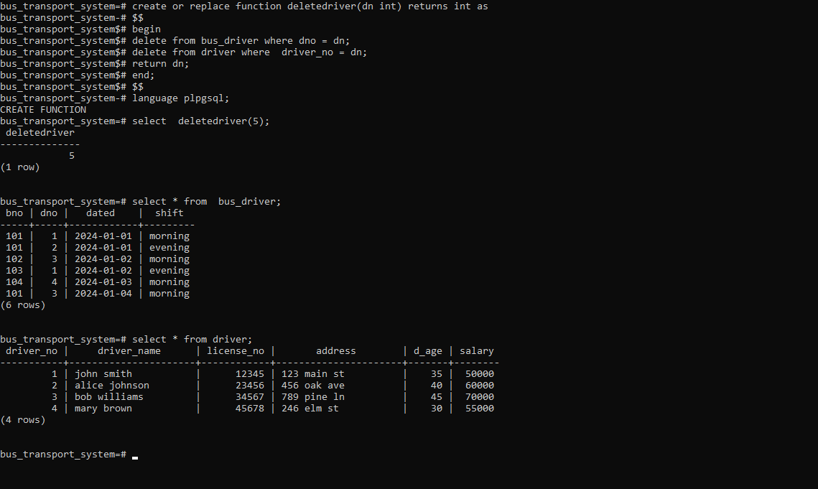

b.

**-- create the database**

create database business_trip_db;

-- \c business_trip_db;

**-- create the dept table**

create table dept (

    deptno varchar(10) primary key,

    dept_name char(20)

);

**-- create the salesman table**

create table salesman (

    sno integer primary key,

    s_name char(30),

    start_year integer,

    deptno varchar(10) references dept(deptno)

);

**-- create the trip table**

create table trip (

    tno integer primary key,

    from_city char(20),

    to_city char(20),

    departure_date date,

    return_date date,

    sno integer references salesman(sno)

);

**-- create the expense table**

create table expense (

    eid integer primary key,

    amount money,

    tno integer references trip(tno)

);

**-- insert data into dept**

insert into dept (deptno, dept_name) values

('D1', 'Home appliances'),

('D2', 'Electronics'),

('D3', 'Clothing');

**-- insert data into salesman**

insert into salesman (sno, s_name, start_year, deptno) values

(101, 'Alice Smith', 2020, 'D1'),

(102, 'Bob Johnson', 2022, 'D1'),

(103, 'Charlie Brown', 2021, 'D2'),

(104, 'Diana Miller', 2023, 'D3'),

(105, 'Ethan Davis', 2019, 'D2');

**-- insert data into trip**

insert into trip (tno, from_city, to_city, departure_date, return_date, sno) values

(201, 'Pune', 'Mumbai', '2024-01-15', '2024-01-20', 101),

(202, 'Mumbai', 'Delhi', '2024-02-10', '2024-02-18', 102),

(203, 'Pune', 'Mumbai', '2024-03-01', '2024-03-05', 103),

(204, 'Delhi', 'Bangalore', '2024-04-12', '2024-04-20', 104),

(205, 'Mumbai', 'Pune', '2024-05-01', '2024-05-05', 101);

**-- insert data into expense**

insert into expense (eid, amount, tno) values

(301, 500.00, 201),

(302, 1200.00, 202),

(303, 750.00, 203),

(304, 1500.00, 204),

(305, 600.00, 205);

**-- 1) function to display names of salesmen from ‘Home appliances’ department**

create or replace function get_home_appliances_salesmen()

returns table (salesman_name char(30)) as $$

begin

    return query

    select s_name

    from salesman

    where deptno = (select deptno from dept where dept_name = 'Home appliances');

end;

$$ language plpgsql;

-- to call the function:

select * from get_home_appliances_salesmen();

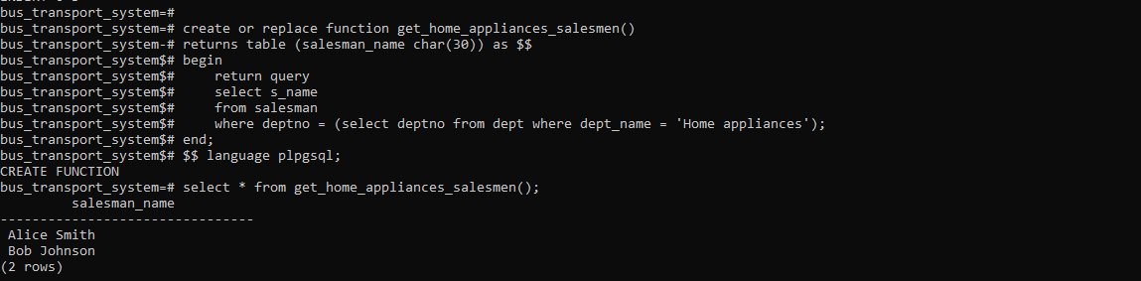

**-- 2) function to find a business trip having maximum expenses**

create or replace function getmaxtrip() returns text as

$$

declare fc text;

tc text;

begin

select from_city , to_city into fc,tc from trip natural join expense where amount = (select max(amount) from expense);

return fc || '' || tc;

end;

$$

language plpgsql;

select getmaxtrip();

getmaxtrip

----------------

DelhiBangalore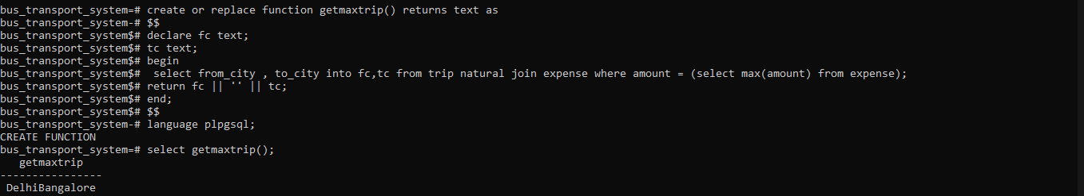

**-- 3) function to count the total number of business trips from ‘Pune’ to ‘Mumbai’**

create or replace function count_trips_from_pune_to_mumbai()

returns integer as $$

declare

    trip_count integer;

begin

    select count(*) into trip_count

    from trip

    where from_city = 'Pune' and to_city = 'Mumbai';

    return trip_count;

end;

$$ language plpgsql;

-- to call the function:

select count_trips_from_pune_to_mumbai();

